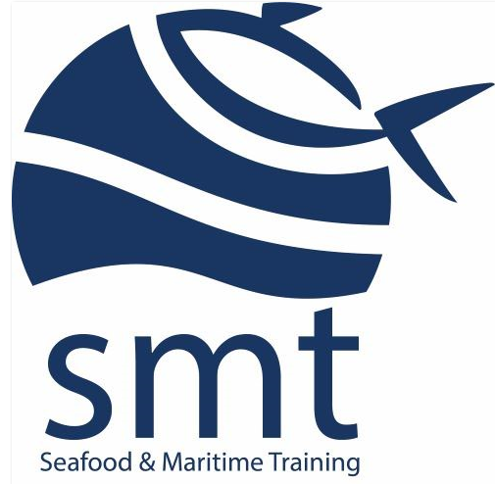
Knowledge Coxswain Deck
Marking Sheet

Trainer / Assessor Instructions for marking of assessment | - This answers within this marking sheet are comprehensive and technically correct as acceptable responses  - Listed below are the questions asked and answers in red  - Assessors must refer to these when considering the responses provided by participants  - A course participant is not expected to provide answers to that level of detail, instead for a satisfactory response, the participant’s answers should be within the range of model answers and meet the minimum required number of responses provided and indicate a basic level of knowledge and understanding of the topic  - Each question must be completed correctly, and the assessor must indicate whether the response is satisfactory in the column against each question on the assessment  - If a verbal answer is given for any questions, the assessor is to document the participant’s answers and initial next to it
Reasonable Adjustment | The purpose of reasonable adjustment is to make it possible for learners to participate fully. A reasonable adjustment in teaching, learning and assessment activity needs to be justifiable and uphold the integrity of the qualification.  Inherent requirements are the fundamental parts of a course that must be met by all students for them to be deemed competent. They are the abilities, skills and knowledge students need to complete the course — those components which, if removed, would compromise the learning outcomes  - Assessors may accept variations of an acceptable response in marking the assessment for example where the benchmark is ‘adequate lighting’ the assessor may also choose to accept variations such as ‘enough lighting, sufficient lighting, good bright lighting.’  - Assessors must ensure the answers provided are comparable to the meaning and intent of the acceptable responses provided.

Part 1 – Ropework and lifting
- How do you work out the Working Load Limit (WLL) of a lifting sling?
Read the label, colour match with manufacturer guide, identify number of strips on sling

- What will you use as maximum WLL if the limit for a crane is 2,000kg and the WLL for the lifting sling is 1,700kg?
1700kg
- Which rope would be chosen for the following applications? Join the ropes with preferred use;

Nylon - Shock loading & elasticity
Polypropylene - Good abrasion resistance/ Floating rope that will not rot
Natural Fibre - Tag lines lifting operations
Flexible Steel Wire Rope (FSWR) - Winch drum & hoist operations

- What are FOUR things you would look for when inspecting ropes for damage?

Burn marks/melting, flattening, kinks, frays, reduction in diameter, damage to core, knots, damaged fibres/cuts

- What are THREE safety considerations when working around ropes and loads under tensions

Do not – stand beneath loads, straddle cable, hold or put hand on cable when under strain, stand directly in line with the cable

Part 2 – Domestic Regulations
- 1. List THREE pieces of Legislation that apply to a Domestic Commercial Vessel (DCV) and its crew?
WHS Act 2012
Navigation Act 2012
Anti-discrimination Act
Workers Compensation Act 1986
Marine Safety National Law Act 2012

- 2. What documentation onboard the vessel outlines the duties, responsibilities, and authority of the Master and crew?

Duties statement within SMS

- 3. What is the minimum crew (core complement) required for a DCV less than 12 metres operating in D class waters?
One
- 4. What are the certification requirements of Master of a DCV less than 12 metres operating in D class waters?
Coxswain Grade II

- 5. Refer to Marine Safety (Domestic Commercial Vessel) National Law Act 2012 Part 5
What must the Master of a vessel do on becoming aware of another vessel in distress?
Obligation to render assistance
(1) The master of a domestic commercial vessel commits an offence if:
(a) the vessel is in any waters; and
(b) the master has reason to believe that one or more persons are in distress on a vessel or in any waters; and
(c) the master does not both:
(i) cause his or her vessel to proceed as fast as practicable to the assistance of the person or persons; and
(ii) inform the person or persons that the master is doing so.
Report of marine incident
- 6. Refer to Part B of the NSCV
What service category would a vessel carting cargo in waters between Triabunna and Darlington on Maria Island fall under?

2D

- Refer to Marine Orders 504
- 7. What are FOUR emergency situations for which crew should receive inductions?

The emergency plan must include procedures for responding to each of the following situations that is relevant to the vessel and its operation:

(a) fire;
(b) a person overboard or unaccountably missing;
(c) a personal injury or other medical emergency;
(d) master incapacitated;
(e) loss of steering;
(f) vessel collision;
(g) vessel grounding;
(h) vessel flooding;
(i) adverse weather or water conditions;
(j) any other circumstance identified by the risk assessment that may require an emergency response.

- Refer to Part B of the NSCV
- What service category would a vessel carrying passengers in waters between Port Arthur and Eaglehawk Neck fall under?
1C

- 9. List four documents that must be accessible to the operator of <12 metre Class 2C surveyed vessel?
Certificate of survey, SMS, Certificate of Operations, Compass deviation card, Life-saving equipment certificate, Life raft servicing certificate, Firefighting equipment certificate, Certificates of Competency (skipper, engineer), Marine Radio Operator's Certificate of Proficiency (and ship station licence for HF radio if relevant), Certificate of Insurance, Safety Management Compliance Certificate.

- What information should you record daily in your vessel logbook?
fuel, area of operations, persons onboard, emergency events, faults/breakdowns, handover items pertinent to the safe use of the vessel
- As the Master of DCV, how do you keep up with changes to the industry and Legislation?
AMSA, MAST and NMSC websites bulletins, Notice to Mariners
- Once changes to regulations and legislation have been identified, what must you do?
Safety Management Plan updates, Operational Policies and procedures reviews, crew induction and briefing, training

- List SIX pieces of safety equipment required for a 10 m 1D vessel as stated in the NSCV Part C Section 7 subsection 7A.
Distress Signals:
- 3 Parachute distress rockets
- 2 Red hand-held flares
- 1 hand-held orange smoke signal
- Manual or water activated EPIRB
Navigation Equipment:
- Clock (May be included in other nav equipment
- Binoculars
- Echo sounder
- Nautical publications
- Speed and distance calculator
- Compass Nav lights
- Sound signal
Onboard communication:
- Signalling light
- VHF radio
- Current edition of the ‘Marine VHF Radio operators handbook
Firefighting equipment:
- Refer to NSCV Part C4
Lifejackets:
- Coastal lifejacket for 100% complement
Part 3 – Anchoring and Beaching
- What are THREE factors you would consider when selecting an anchorage?

Depth; bottom composition; swing room; changes in tide and weather; ease of moving in case of inclement weather

- Select the anchor when anchoring on a soft mud seabed (circle your answers)
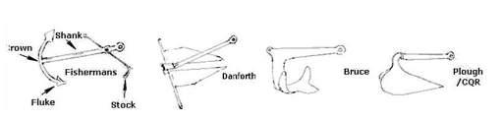
- What are TWO ways you can check whether an anchor is dragging?

Identify position – transits shift (other than swing); feel vibration and dragging through anchor cable; position of vessel relative to wind/current; Change of sound from anchor chain
- List THREE things you can do if your anchor is dragging?

Reset anchor; use different type of anchor; lay out second anchor; seek more sheltered anchorage or one with different bottom composition, increase scope
- What are TWO emergencies that might lead to you beaching a vessel?

Vessel flooding, offload injured persons, fire damage, NUC
- What are THREE considerations for re-floating a beached vessel?

Ensure tide suitable, inspect hull for damage, check bilges, remove water or items adding to weight of vessel, brief crew on process, check weather conditions, determine if support vessel is required, ensure bilge systems and safety equipment are in working order, secure loose items

Part 4 – Pre-start checks/Voyage Planning and Refuelling
- What would you do if any equipment required on your vessel by NSCV is not functioning?
Replace or repair if competent to do so.
Adhere to SMS
Lock out, tag out to ensure not used
Notify vessel owner or DPA
Detail findings in vessel logbook

- Would your vessel be seaworthy if not rectified? No

- Name THREE pieces of equipment you would test prior to departure?
Steering gear, sound signalling device, radio/EPIRB, navigation equipment, engine and machinery, engine controls, remote bilge alarms and pumps

- What fuel consumption will you anticipate for the day if your voyage plan involves eight (8) hours of operation, and your fuel consumption is twelve (12) litres per hour? 96

- 120-144
- Check fuel level in tank at a certain time and then check again after 1 hour. The difference will be your hourly consumption rate. Sound tanks to verify against gauges (if fitted)
- When would you report a fuel spill to authorities?
Asap once spill is controlled or contained, then be prepared to follow instructions

- What are three precautions that will help to reduce the risk of a spill when refuelling?

estimate how much fuel required, block freeing ports, maintain communication with fuelling person, follow SMS process, place bucket under vents, vessel held fast,

- What systems or equipment should you shut down prior to any refuelling?

LPG, engines and other machinery, anything likely to cause sparks or heat

- What activities should be restricted within a ‘safety zone’ while refuelling?

Smoking, talking on the phone, welding, grinding, hot work, anything likely to cause ignition

- In the event of a spill while refuelling, what procedures should you follow?

Vessel SMS procedures -Shut down fuelling system; prevent further spillage, fire-fighting equipment available, contain using spill kit and bunding, alert personnel; alert authorities; clean up any spillage aboard

Part 5 - Outboards
- If you couldn’t start the outboard motor, list THREE checks you would make?

lack of fuel, filter clogged, hoses not connected properly or kinked, spark plug, shift lever in gear, lanyard stop switch

- When using a motor, what are FOUR pre-start checks you should make?

mounting bolts/screws, throttle/gear shift operation, fittings for looseness, reverse-lock mechanism, 2-stroke oil usage (if applicable), anodes, steering range, safety switches

- Name TWO hazards association with batteries?

Risk of spark, gas produced by batteries in confined/restricted spaces, incorrect fitting or - + cables, battery explosion, eye contact with battery acid, manual strain moving batteries

- What are THREE post-start checks you should make if the engine if running roughly?

Check fuel connection
Ensure prop and leg not restricted or damaged
Check oil level (mix and sump as applicable)
Cooling system-water transfer
Spark plug and timing
Part 6 – Environmental considerations
- Ho w many Annex make up the International Convention for the Prevention of Pollution from Ships (MARPOL)?
6
- What provision should you make for garbage disposal, and recyclables when operating a small vessel within 10nm of shore to comply with MARPOL?

Bring it back – no disposal of rubbish overboard (and small vessels don’t normally have pulverisation gear on board)

- What are the advantages of compacting waste onboard your vessel

Greater space and storage ability.
Control of waste into designated types for disposal post voyage
Containing on board

3a List one (1) way of compacting ‘general’ waste on a DCV.
Manually
Deck machinery to fold or compact
Compacting unit (hydraulic)

- How should you store fuel, waste oil and chemicals on your vessel?

Refer to product SDS. Designated container shall be marked, vented (if required), and crew briefed of storage and handling, secured correctly
- Where can you discharge sewage at sea in Tasmania?
Vessels to which this Part applies must not discharge sewage that is not disinfected
in any of the following waters:
Open waters >1nm from land (including islands)
- Great than 5metres deep;
- Greater than 120m of person in the water

- List TWO environmental impacts from the following;
Anchoring
1. Disturbing the seabed
2. Damage to marine life
3. Unearthing contaminated seabed
Noise
1. Disturbing animals resting or nesting
2. Hearing loss
3. sonar impact to navigating marine life
4. Impact to natural habits of wild animals
Propeller wash
1. Erosion to shoreline
2. Churning up seabed in shallow water
3. waves impacting coastal sensitive areas

Part 7 - Construction and Maintenance
- Why are watertight compartments important?

Buoyancy; watertight integrity of vessel; prevent sinking in case of penetration of individual compartments

- When inspecting the integrity and condition of a hull, what are THREE signs of stress you would look for?

Cracks, buckling, damage to welds, damage beneath paint, signs of leakage

- What types of damage or deterioration would you look for in vessels constructed of the following?

Steel: rust, electrolysis, poor welds, other
Wood: rot, damage, deterioration of fastenings, attack by marine life, other
Aluminium: electrolysis, corrosion, cracks, other
Fibreglass: osmosis, cracks, damage to gelcoat, delamination, other

- Identify the following structural parts of a vessel and place appropriate numbers by each part

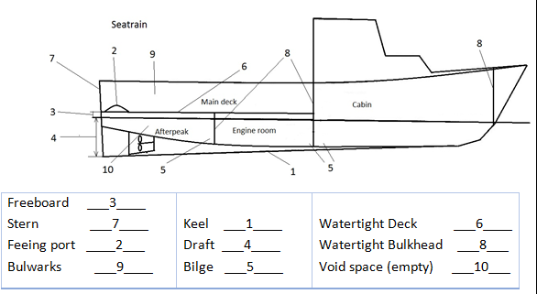

- List two (2) areas where water can enter the vessel whilst at sea

Engine hatch
Deck mounted pipework
Wheel house
Watertight doors or hatches on deck
Stern Tube

